**Experiment 1**

**Aim:** To verify and interpret the logic and truth table for AND, OR, NOT, NAND, NOR, Ex-OR, Ex-NOR gates.

**Tools Used:** Circuit Verse and Virtual Labs.

**Theory:** Logic gates are the basic building blocks of any digital system. Logic gates are electronic circuits having one or more than one input and only one output. The relationship between the input and the output is based on a certain logic. Based on this, logic gates are named as

* AND gate
* OR gate
* NOT gate
* NAND gate
* NOR gate
* Ex-OR gate
* Ex-NOR gate

AND gate: The AND gate is an electronic circuit that gives a high output (1) only if all its inputs are high and low output (0) when all or any one input is low. A dot (.) is used to show the AND operation i.e. A.B or can be written as AB.

**Y=A.B**  
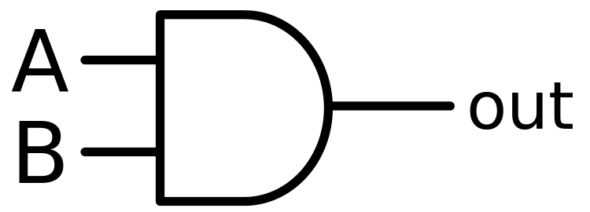

*Fig 1: Symbol of AND Gate*

|  |  |  |
| --- | --- | --- |
| A | B | Y(Output) |
| 0 | 0 | 0 |
| 0 | 1 | 0 |
| 1 | 0 | 0 |
| 1 | 1 | 1 |

*Table 1: Truth Table of AND Gate*

OR gate: The OR gate is an electronic circuit that gives a high output (1) if one or more of its inputs are high and gives lower output (0) when if all the inputs are low. A plus (+) is used to show the OR operation.

**Y= A+B**

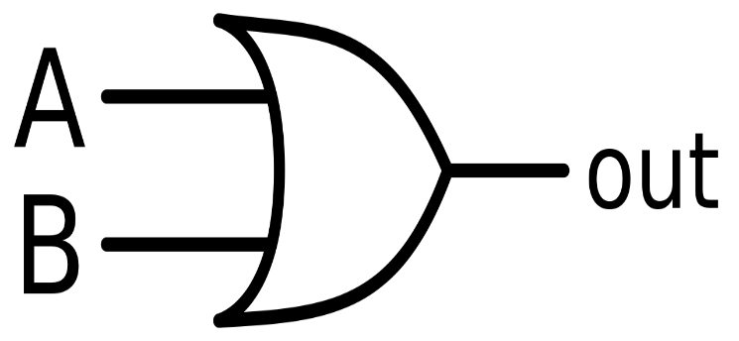

*Fig 2: Symbol of OR Gate*

|  |  |  |
| --- | --- | --- |
| A | B | Y(Output) |
| 0 | 0 | 0 |
| 0 | 1 | 1 |
| 1 | 0 | 1 |
| 1 | 1 | 1 |

*Table 2: Truth Table of OR Gate*

NOT gate: The NOT gate is an electronic circuit that produces an inverted version of the input at its output i.e. it gives low output (0) when high input (1) is passed and it gives high output (1) when low input (0) is passed. It is also known as an inverter. If the input variable is A, the inverted output is known as NOT A. This is also shown as A' or A with a bar over the top, as shown at the outputs.

**Y= A'**

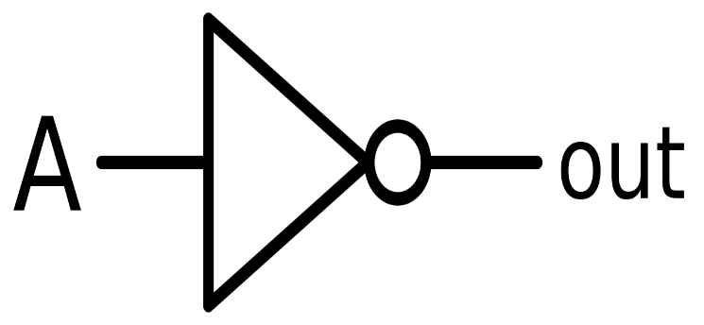

*Fig 3: Symbol of NOT Gate*

*Table3: Truth Table of NOT Gate*

|  |  |
| --- | --- |
| A | Y(Output) |
| 0 | 1 |
| 1 | 0 |

NAND gate: This is a NOT-AND gate which is equal to an AND gate followed by a NOT gate. The outputs of all NAND gates are high if any of the inputs are low. The symbol is an AND gate with a small circle on the output. The small circle represents inversion.

**Y= (A.B)’**

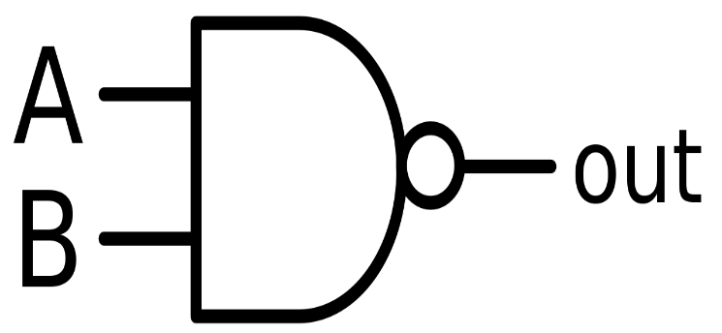

*Fig 4: Symbol of NAND Gate*

|  |  |  |
| --- | --- | --- |
| A | B | Y(Output) |
| 0 | 0 | 1 |
| 0 | 1 | 1 |
| 1 | 0 | 1 |
| 1 | 1 | 0 |

*Table 4: Truth Table of NAND Gate*

NOR gate: This is a NOT-OR gate which is equal to an OR gate followed by a NOT gate. The outputs of all NOR gates are low if any of the inputs are high. The symbol is an OR gate with a small circle on the output. The small circle represents inversion.

**Y= (A+B)’**

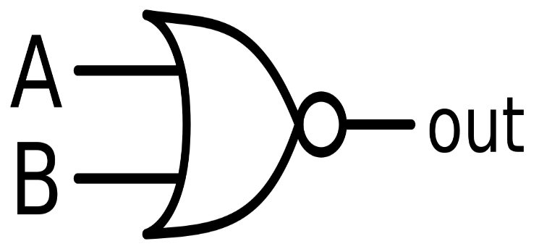

*Fig 5: Symbol of NOR Gate*

|  |  |  |
| --- | --- | --- |
| A | B | Y(Output) |
| 0 | 0 | 1 |
| 0 | 1 | 1 |
| 1 | 0 | 1 |
| 1 | 1 | 1 |

*Table 5: Truth Table of NOR Gate*

Note: NAND and NOR Gate are Universal Gates. Universal Gate is a gate which can implement any Boolean function without need to use any other gate type.

Ex-OR gate: The 'Exclusive-OR' gate is a circuit which will give a high output if either, but not both of its two inputs are high. An encircled plus sign (⊕) is used to show the Ex-OR operation. Ex-OR gate is created from AND, NAND and OR gates. The output is high only when both the inputs are different.

**Y= A⊕B**  
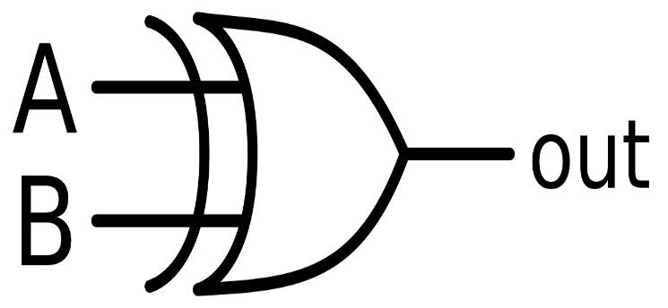

*Fig 6: Symbol of Ex-OR Gate*

|  |  |  |
| --- | --- | --- |
| A | B | Y(Output) |
| 0 | 0 | 0 |
| 0 | 1 | 1 |
| 1 | 0 | 1 |
| 1 | 1 | 0 |

*Table 6: Truth Table of XOR Gate*

Ex-NOR gate: The 'Exclusive-NOR' gate circuit does the opposite to the EX-OR gate. It will give a low output if either, but not both of its two inputs are high. The symbol is an EX-OR gate with a small circle on the output. The small circle represents inversion. Ex-NOR gate is created from AND, NOT and OR gates. The output is high only when both the inputs are same.

**Y= (A⊕B)’**

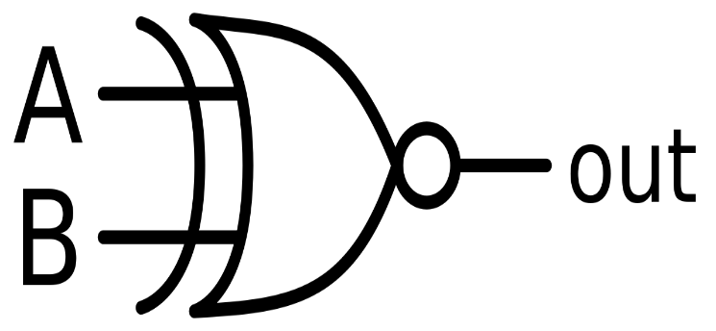

*Fig 7: Symbol of Ex-NOR Gate*

|  |  |  |
| --- | --- | --- |
| A | B | Y(Output) |
| 0 | 0 | 1 |
| 0 | 1 | 0 |
| 1 | 0 | 0 |
| 1 | 1 | 1 |

*Table 7: Truth Table of XNOR Gates*

**Observations:**

Circiut Represenation of:

1. AND Gate:

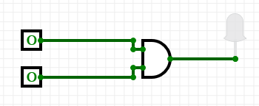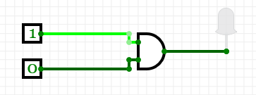 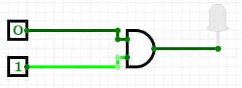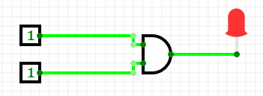

1. OR Gate:

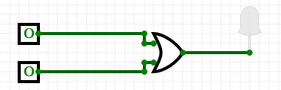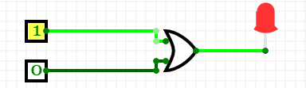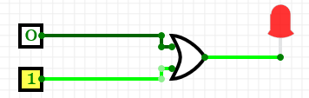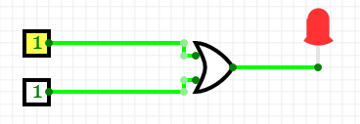

1. NOT Gate:

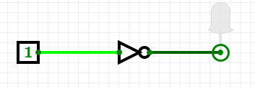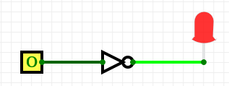

1. NAND Gate:

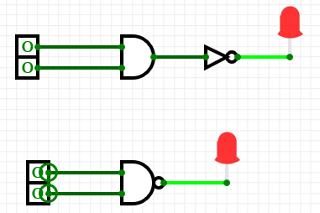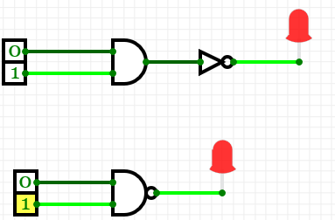 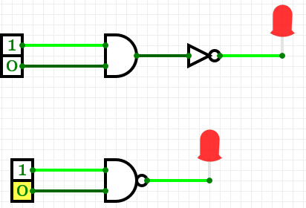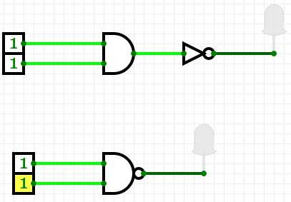

1. NOR Gate:

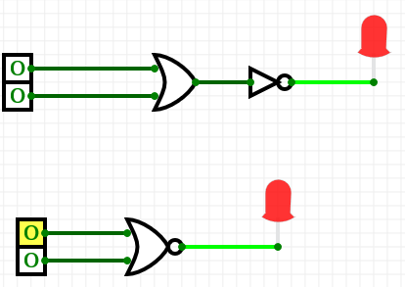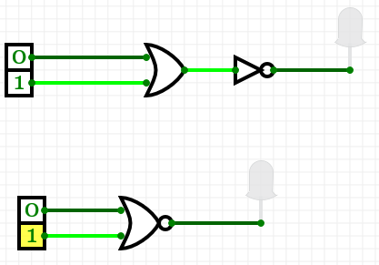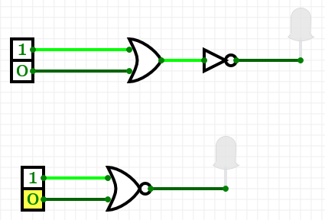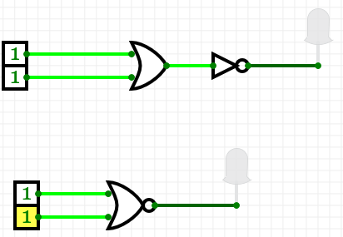

1. Ex-OR:

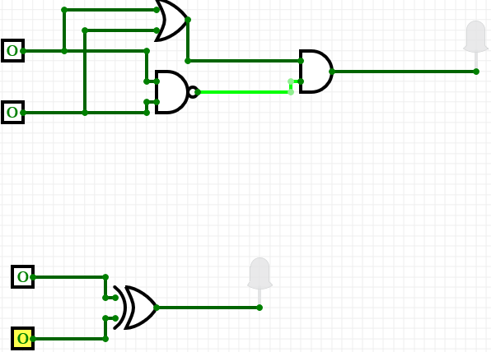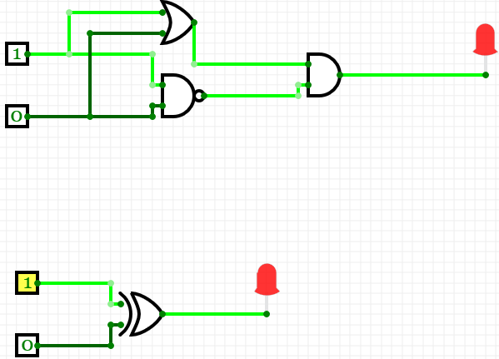

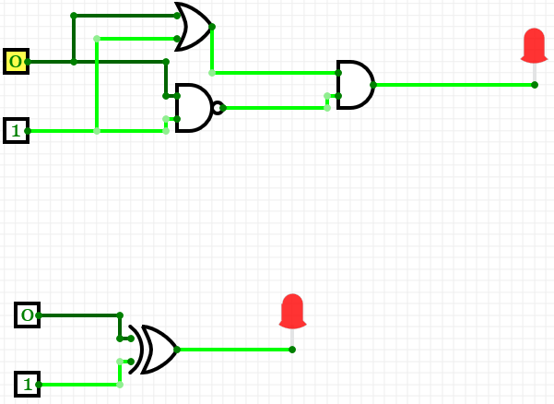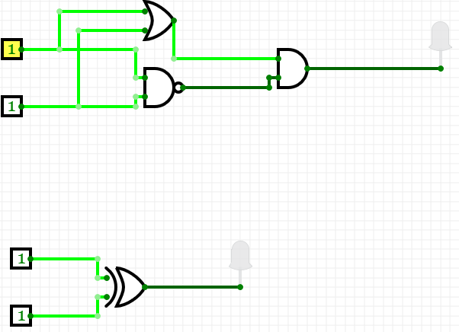

1. Ex-NOR:

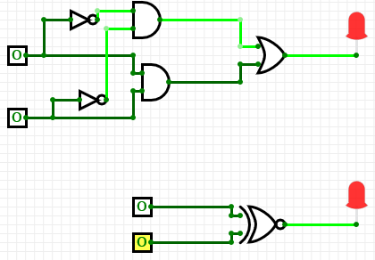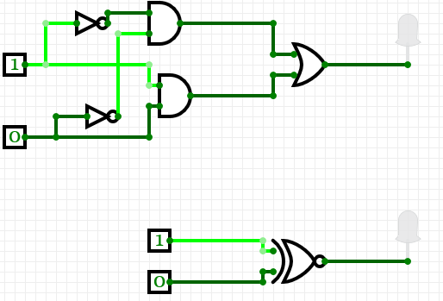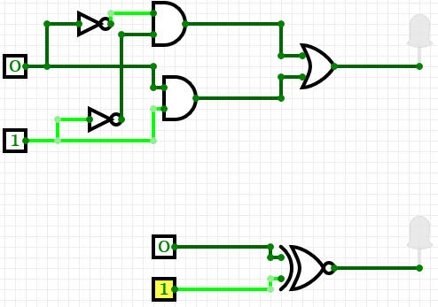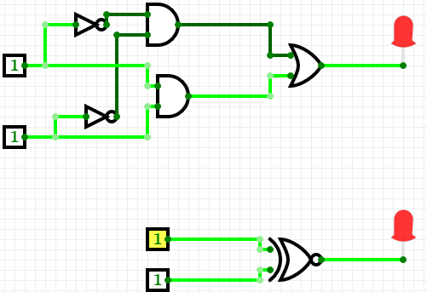

**Result:** The truth table of AND, OR, NOT, NAND, NOR, Ex-OR, and Ex-NOR gates have been verified.

|  |  |  |  |
| --- | --- | --- | --- |
| **CRITERIA** | **TOTAL MARKS** | **MARKS OBTAINED** | **COMMENTS** |
| 1. **CONCEPT** | **2** |  |  |
| 1. **IMPLEMENTATION** | **2** |  |  |
| 1. **PERFORMANCE** | **2** |  |  |
| **TOTAL** | **6** |  | |